



# Background

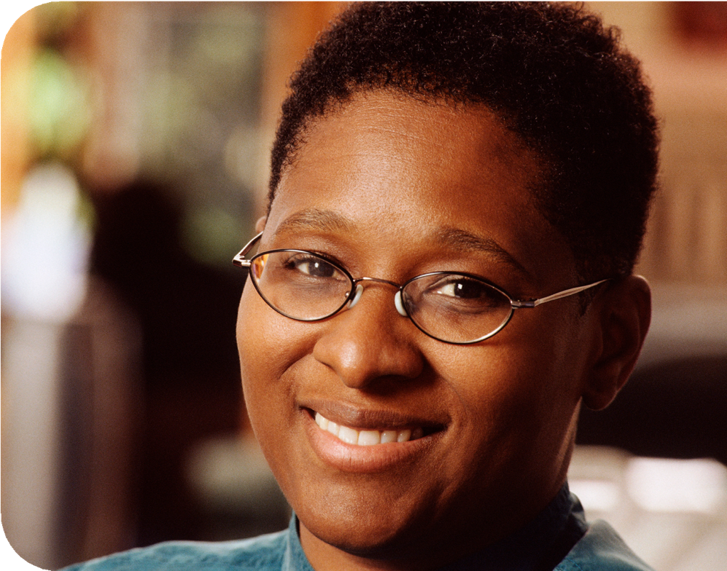

The CPCAB model of helping work and counselling practice

The first version of the CPCAB model was developed during an educational design research1 programme in the late 1980’s and early 1990s2 that sought to identify the core elements of counsellor proficiency and their development in counselling training. Since then, the CPCAB model has been updated to reflect (1) a broad range of research findings, including for example the various factors that contribute to therapeutic change; and (2) a wide range of practice insights gained from the model’s application across thousands of counselling courses. This latest version of the model is therefore informed by both contemporary interdisciplinary research and extensive educational practice.

The CPCAB counselling qualifications progression route is based on this model, which defines the depth and focus of each level of training and articulates the associated increase in the learner’s knowledge, skills, proficiency, and autonomy. Over the last 23 years more than 150,000 helping and counselling students have trained on courses based on the CPCAB model.

1. See, for example, Akker, Jan V.D. et al. (ed.) (2006) *Educational Design Research*. New York: Routledge.
2. Crouch, A. (1992). *The Competent Counsellor*. Self and Society: European Journal of Humanistic Psychology, 20:3, 22-25.

**Overview of model** Focus of the models

Counselling was originally founded in the 1940’s3 as a direct challenge to the traditional medical model – a model that reduces client problems to specific symptoms, each requiring specific

treatments. This “reductionist” approach necessarily excludes the context of client

problems (see Part 1 and Part 2) together The traditional medical model: The CPCAB model:

with a range of contextual factors that have been shown to be critically

focus on symptoms client problems in context

* Treatment factors Treatment factors ✓



✗ Doctor factors Counsellor factors ✓

important elements of the counselling ✗ Doctor-patient relationship factors Relationship factors ✓

process (see Part 3).

✗ Patient factors Client factors ✓

The counselling approach challenges, therefore, the reductionism of the traditional medical model by providing an alternative “whole systems” perspective in which client problems, client change and the process of supporting client change (the counselling process) are all inextricably connected to their context.

Following on from this, the CPCAB model sets out the essential elements of practice that are common to all counselling approaches. It describes how counsellors can support clients to change and consists of three parts:

**Part 1: three levels of client problems**. This defines the broad categories of client problems for which counselling has proved helpful:

* Service Level A: Everyday life problems; and...
* Service Level B: Common mental health and other psychological problems (which, the model proposes, may have both an explicit and implicit aspect).

This first part of the model also defines a 3rd broad category of client problems: (Service Level C) severe and complex mental health problems.

**Part 2: three dimensions of client problems**. This describes how client problems can be best understood, and worked with, in the *context* within which they arise. For everyday life problems the context is (1) the person’s thoughts and feelings in (2) their relationships and (3) particular life stage. For common mental health and other psychological problems, the model proposes a similar three-dimensional psychological context within which those problems have developed.

1. Rogers, Carl R. (1942) *Counselling and Psychotherapy: Newer Concepts in Practice*. Boston: Houghton Mifflin Company.

**Part 3: seven helping and counselling processes**. This describes how the process of supporting client change is associated with a range of contextual factors – including those concerning the client, the counsellor, and the relationship that they form. Following on from this, and drawing on a wide range of research, part 3 of the model describes seven processes that weave together to form the counselling process.

Parts 1, 2 and 3 of the model fit together into a coherent matrix:

Overview of CPCAB model

Part 1: Three levels of client problems

# Part 1: three levels of client problems

7

6

Part 2: Three dimensions of client problems

5

4

3

2

1

Part 3: The counselling process

|  |  |  |  |
| --- | --- | --- | --- |
|  | 1 | 2 | 3 |
| A |  |  |  |
| B |  |  |  |
| C |  |  |  |

All professions define a set of real-world problems which they aim to manage, and which therefore delineate their professional domain. Counselling has proven to be effective with the following broad categories of client problems:

* Service Level A: Everyday life problems
* Service Level B: Common mental health and other psychological problems

Counselling can also be helpful for a 3rd broad category of client problems – Service Level C: Severe and complex mental health problems.

*Service Level A. Helping work and counselling: everyday life problems*

Problems with our parents, or when we first become a parent … problems with our partner, or with the loss of our partner… problems with our work, or with not having work… problems with our lifestyle such as our weight, our drinking or our smoking… problems that gradually build up over time (because we ignore them), or problems that suddenly “hit us in the face”… life is full of these everyday life and lifestyle problems.

In the past, researchers tended to assume that we faced all these problems alone. However, recent research on everyday problem-solving4 has shown that not only do we often seek help from friends and family, but also that partners regularly solve problems together. So, most of the time, with a little help from our friends and family, we cope reasonably well with our everyday life problems.

Sometimes, however, we can get overwhelmed and “stressed out”5 and in these kinds of situations a helper or counsellor can provide much needed support.

An extensive body of research on the stages of change6 has concluded that as many as 80% of people are not ready, at the point when they seek professional help, to make changes. Instead, they are either in a “pre contemplation” stage where they are insufficiently aware of (or avoiding) their problems, or in a “contemplation” stage where they are exploring their problems but not yet ready to make changes. So, what kind of help do these clients or helpees7 need?

The perspective of the CPCAB model is that problems do not exist in isolation but are instead intimately connected with their context. Clients need, therefore, to explore this context before they are ready to focus on making changes – they need to explore how their problems arise from, and are connected to, themselves and their life (see Part 2).

An important aspect of this context is the client’s stage of change, and one of the key recommendations of the research cited above is that the counselling service can be usefully tailored to this – i.e., that clients who are in (1) the pre-contemplation stage can be supported to develop their awareness of themselves, together with the advantages of changing, while those in (2) the contemplation stage can be supported to:

1. Explore their thoughts about themselves, their life, and their problems with the aim of developing associated insights and self-re-evaluations.
2. Explore their feelings about themselves, their life, and their problems with the aim of developing emotional understanding and awareness together with readying themselves to emotionally move forward and change.
3. Develop a belief in their ability to change together with an associated commitment to change.
4. See, for example, various research publications by Cynthia A. Berg (and colleagues) on “everyday problem solving in context”.
5. This section of the CPCAB model on everyday life problems is informed by research on stress, coping and resilience.
6. The stages of change model were originally developed by Prochaska & DiClemente in 1977 and has been extensively researched over nearly four decades. See, for example, Chapter 14 in Norcross, J. C. (ed.) (2011) *Psychotherapy relationships that work: Evidence-Based Responsiveness*. New York: Oxford University Press.
7. The term “client” refers to people working with a counsellor while “helpee” refers to those working with a helper.

Once a person has made a firm commitment to change, they can then be supported to (3) prepare for and then (4) make the necessary changes. Finally, they can be supported to (5) maintain those changes.

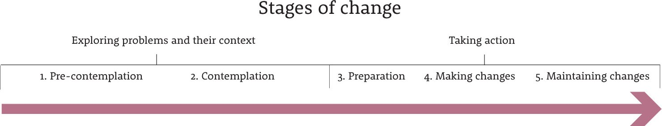

Informal helping work may be able to provide the support needed to cope with everyday life problems, but sometimes a person will need to see a counsellor, who can provide a more in- depth supportive relationship. Additionally, some people who are not yet ready to make the (Level A) life or lifestyle changes8 may first need to work with a counsellor on an underlying psychological problem (Level B – see below). For example, a client and counsellor might agree on the goal of stopping smoking, but as the counselling progresses it becomes clear that smoking is not only a *problem* but also a *solution* in that the client uses smoking to soothe their social anxiety9. The client and counsellor both realise, therefore, that to achieve the (Level A) goal of stopping smoking they will first need to deepen the level of work (to Level B) and focus on the underlying social anxiety.

*Service Level B. Counselling: common mental health and other psychological problems* Sometimes, as in the example above, the core problem is not so much in our life but within ourselves … and many clients come to counselling for help with these *psychological* problems. The traditional medical model defines these as mental health problems, which are normally divided into *common* mental health problems (such as anxiety and depression) and *severe and complex* mental health problems (such as bipolar disorder and schizophrenia: see Level C below). The CPCAB model proposes that, rather than simply focusing on the treatment of symptoms, these psychological problems are best understood, and worked with, in the context of the person within whom they develop.

1. Counselling has proved effective for a range of health issues and lifestyle changes and is therefore becoming a key element of health service provision.
2. Much of the research on the stages of change concerned smoking cessation. A strong link between mental health problems and smoking has also been identified: a 2010 NatCen report, for example, found that one-third of people with common mental health problems and 57% of people who attempted suicide were smokers, while a 2015 Public Health England survey concluded that mental health patients smoke three times as much as the general population and that smoking is the primary reason why these patients have a lower life expectancy of 15-20 years.
3. This research includes explicit/implicit emotions and cognition, dual process theory, explicit/implicit social cognition, explicit autobiographical memory, and implicit emotional memory.

As mentioned above, one important aspect of this context is the client’s stage of change, including the level of awareness of their problem. Drawing on the research on the stages of change, together with research on the “explicit” and “implicit” nature of our thoughts and feelings, relationships and memory10, the CPCAB model proposes that working with psychological problems can involve both an explicit (B1) and implicit level (B2).

In the above example the client begins counselling wanting to stop smoking (Level A) but also with an implicit psychological problem (Level B2) and therefore in the pre-contemplation stage with respect to this underlying problem. Later in the counselling process, when it becomes clear that the underlying problem is their social anxiety, this implicit problem moves to the explicit, contemplation stage (Level B1) and client and counsellor are then able to explore it together.

It is important to note that when working at the explicit level with a client it may be possible to proceed in a goal-directed way towards change, but the process of supporting clients to change implicit aspects of themselves (that they may be avoiding) can be more complex. Together with developing their awareness of themselves and the advantages of changing, this level of work may also, for example, involve the client developing a deeper level of trust, not only with their counsellor but also within themselves.

*Service Level C. Severe and complex mental health problems*

This aspect of the CPCAB model is informed by research on early childhood development during which time the *foundations* of the person are developed. The model proposes that these foundations include experiences such as the person’s core sense of being-at-home-in- themselves and being-in-the-world-of-others, together with their core sense of their own development process (i.e., their “ontogeny” as a person).

*Tailoring helping and counselling to the level of client problems:*

The model proposes that clients categorised with severe and complex mental health problems may be helped by working on aspects of the foundations of themselves, but only with a counsellor who is trained and experienced to work with this level of client problems and normally in conjunction with other services. Clients with severe and complex mental health problems will normally, therefore, need to be referred to, for example, the psychiatric provision of secondary mental health services.

|  |
| --- |
| Level A Helping work and counselling: everyday life problems |
| Level B1 Explicit Counselling: common Level B2 Implicit health and other  psychological problems |
| Level C Severe and complex mental health problems |

The CPCAB model proposes that helping and counselling can be usefully tailored not only to the client’s stage of change, but also to the *level* of client problems. However, it’s important to note that this “map” is only a map and not the “territory”. Clients may present, for example, with a mixture of interconnected problems at differing levels and the stages may be more spiral in nature than linear. In other words, real life, and real-life counselling, can be much more challenging, and profound, than this map.

# Part 2: three dimensions of client problems

Part two of the CPCAB model is based on a “whole systems” approach to understanding client change in relation to both everyday life problems and psychological problems. From this perspective client problems both arise from, and remain connected to, their context. Client problems are “context-dependent” and client change requires, therefore, working with both problems and their context. The CPCAB model proposes that this context consists of three dimensions:

## Three dimensions of client problems: 1.) Internal dimension 2.) Relational dimension 3.) Developmental dimension Service Level A: everyday life problems11

With everyday life problems counsellors can support client change by working with the:

1. Internal dimension: thoughts and feelings
2. Relational dimension: relationship issues
3. Developmental dimension: life stage issues

When, for example, someone has an accident they must cope with the physical effects. There are often, however, “knock- on” effects on relationships and the ability to cope with the challenges of the particular life stage. A young mother with a physical injury, for instance, might find it much harder to care for her child, and her relationship with her partner might also deteriorate (relational dimension). As a result of her injury, she might also have to give up her work and associated career (developmental dimension). All of this also has profound effects on her inner life – on her thoughts and feelings (internal dimension).

## Service Level B: common mental health and other psychological problems 12

With common mental health and other psychological problems counsellors can support client change by working with:

1. This section of the CPCAB model is informed by, for example, research on (1) emotional regulation; (2) social problem- solving; and (3) the life course.
2. This section of the CPCAB model is informed by, for example, research on (1) emotional and cognitive systems; (2) social neuroscience; and (3) explicit autobiographical memories and implicit emotional memories.
3. *The internal dimension: changing the way clients relate within themselves:*

Clients may not be able to change who they are, but they can often change the ways that they relate within themselves – changing, for example, an internal conflict between the “head” and the “heart” into a more collaborative inner dialogue.

Different theories and techniques offer different ways of understanding and working with this dimension. The Freudian model of id, ego and super-ego is one such theory, but there are many others. In Transactional Analysis, for example, the counsellor might help the client to uncover a conflict between an angry internal parent and an anxious internal child and then work to change this internal relationship for the better. A CBT counsellor, on the other hand, might support the client to change their habitual thinking patterns, a person-centred counsellor might work with the client to understand the conflict between different parts of themselves, whilst a transpersonal counsellor might support the client to use mindfulness, meditation, and contemplation to develop a greater sense of inner peace.

As clients learn to relate more collaboratively within themselves, they develop a more resilient sense of themselves – enabling them to cope more effectively with their everyday life problems.

1. *The relational dimension: changing the way clients relate with others:*

Clients may not be able to change other people, but they can often change their ways of relating with others – their habitual patterns of perceiving, communicating, and behaving with their partner, parents, children, friends, or colleagues.

These changes often need to initially take place within the safety of the counselling relationship, where the client can test out new ways of relating. By changing their unhelpful patterns of relating, clients develop better ways of coping with difficulties in their relationships and are consequently able to develop more open, supportive and resilient relationships that directly contribute to their health and well-being.

1. *The developmental dimension: changing the way clients relate with their past:* Clients cannot change the past, but they can often change the ways that they relate with their past. They can, for example, change the autobiographical stories that they

tell themselves about their development across the life course or change their implicit emotional response to past traumatic events.

As clients change the ways that they relate with their past, they become more resilient within themselves through, for example, letting go of blaming themselves or feeling less overwhelmed in the present by emotionally painful memories from the past.

Importantly, the model also proposes that the theories and techniques (the treatments) that have been developed across the broad range of counselling approaches can be usefully organised into these above three dimensions.

# Part 3: seven helping and counselling processes

All clients come to counselling because they want to change something. Recent research has demonstrated that counselling works best when the client instigates change supported by a particular kind of therapeutic context in which the counsellor utilises, not just their theoretical understandings and skills, but themselves and the counselling relationship, together with an ethical and reflective approach to their work.

*Factors common to all counselling approaches:*

Contemporary research has confirmed that the primary contribution to effective counselling is made, not by any specific treatment, but rather by the context-dependent factors that are common to all the approaches13. These context-dependent factors are known, in the counselling and psychotherapy research literature, as the “common factors”. They consist of:

1. Client factors – which can be divided into those which can be observed (the difference and diversity of every client, including their community and culture) and those that can only be inferred14 (the client’s subjective experience, stage of change, expectations, characteristics, and preferences, e.g., motivation, hope, etc).
2. Counsellor factors – these can also be divided into observed and inferred factors. The counsellor’s observed factors again concern their difference and diversity (e.g., gender and ethnicity), while the inferred factors include, for example, their level of “healing involvement”15 and their use of self-awareness in the counselling process.
3. Relationship factors – the quality and effectiveness of the counselling relationship.

Evidence for the importance of these categories of common factors comes, for example, from a recent American Psychological Association Research Task Force (Norcross16). Their meta-study encompassed 100,000 clients across more than 400 quantitative research studies and concluded that the common factors make the greatest contribution to client change – with client factors being the most important of all.

1. Treatment factors – the above study, together with other research, also concluded that treatment factors make an important contribution to therapeutic change. The CPCAB model proposes, however, that there are important aspects of treatment factors that are common to all the counselling approaches – and the second part of the CPCAB model (as described earlier) provides a generic framework for organising these commonalities.

So taken together there are four categories of context-dependent factors that contribute to therapeutic change.

Drawing heavily on the research into the factors that contribute to client change, the third and final part of the CPCAB model proposes a “whole systems” approach to the counselling process in which a broad range of factors support client change:

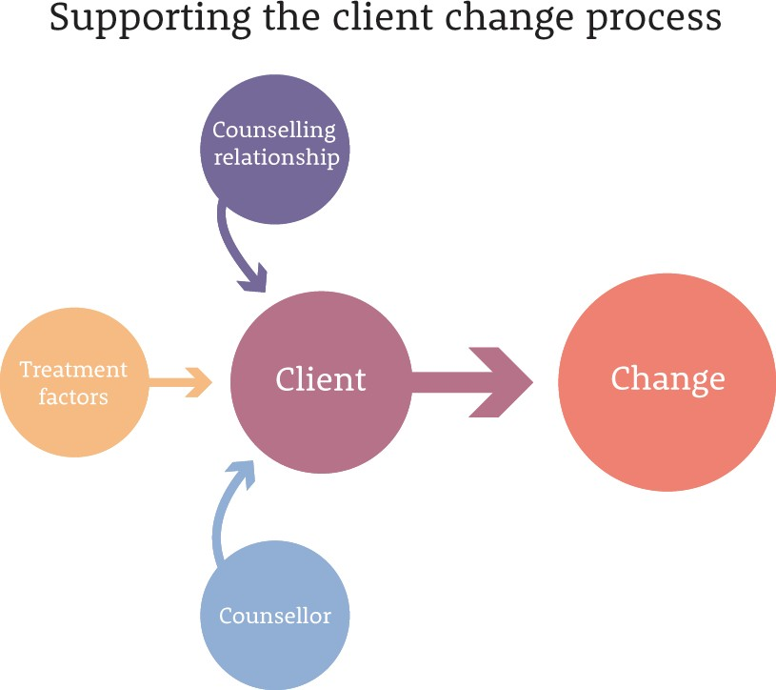

* Client factors – the client as the primary agent of change. The counsellor seeks to understand the client in terms of, for example, their difference and diversity, their unique subjective life, and their stage of change (etc), in order to support the client’s change process.
* Counsellor factors – this is the contribution that the particular counsellor makes to the counselling process (as distinct from the counselling relationship or the use of specific theory and techniques). It includes, for example, the counsellor’s level of healing involvement (see research cited above) together with their ability to use self-awareness in the counselling process.

1. Bruce Wampold and Zac Imel (2015) propose a contextual model of therapeutic change in the 2nd edition of *The Great Psychotherapy Debate,* New York: Routledge.
2. This distinction between observed and inferred factors was proposed by Louis G. Castonguay and Larry E. Beutler (ed.) (2006) in *Principles of Therapeutic Change That Work*. New York: Oxford University Press.
3. This is a measure of some key aspects of the counsellor’s contribution to the counselling process - see, for example, Michael Helge Ronnestad, Thomas Skovholt (2012) *The Developing Practitioner* New York: Routledge.
4. Norcross, J. C. (ed.) (2011) *Psychotherapy relationships that work: Evidence-Based Responsiveness*. New York: Oxford University Press.

* Relationship factors – a broad range of research has concluded that the counselling relationship makes a major contribution to client change.
* Treatment factors – the theory and techniques of the specific counselling approach.
* Professional factors – two other key elements of helping and counselling practice:
  + working within an ethical and professional framework
  + working as a reflective practitioner

The model proposes that these two professional-practice processes support and contain the counselling process.

Common factors

Treatment Professional factors factors

|  |  |  |  |  |
| --- | --- | --- | --- | --- |
|  |  |  |  |  |
| Client factors | Counsellor factors | Relationship factors | Treatment factors |
| 3. Difference & Diversity | 5. Self awareness | 2. Relationship | 6. Theoretical | 1. Ethical & professional |

Taken together, the factors listed above form seven helping and counselling processes – seven processes that support client change:

Processes

4. Focus on helpee/client

Framework

framework

7. Reflective practice

1. 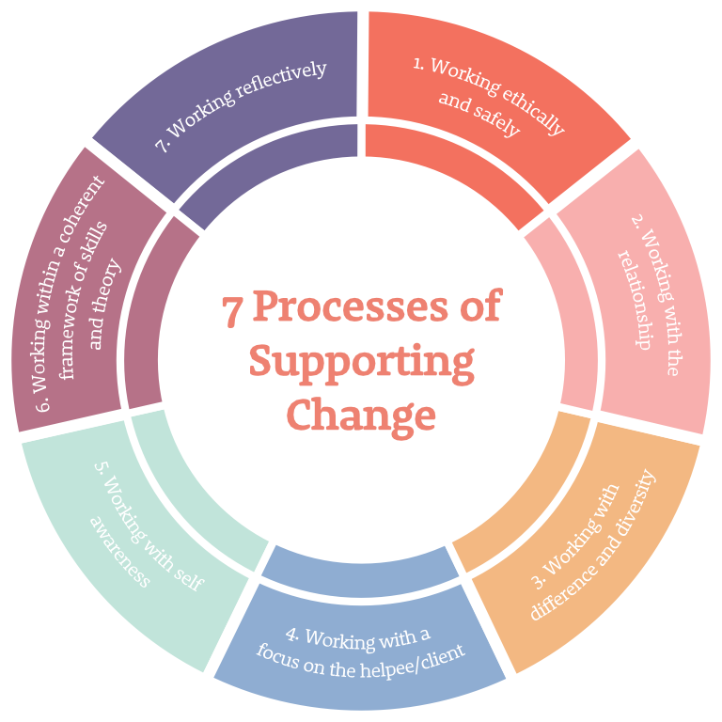Working ethically and professionally (professional factors)
2. Working with the relationship (relationship factors)
3. Working with difference and diversity (observed client factors)
4. Working with a primary focus on the client (inferred client factors)
5. Working with self-awareness (observed and inferred counsellor factors)
6. Working within a coherent framework of skills and theory (treatment factors)
7. Working reflectively (professional factors)

These seven processes do not exist in isolation from each other, but continually interact. They are, therefore, a bit like seven “balls” which the helper or counsellor “juggles” when supporting their helpees or working with their clients. Helpers can work with these seven processes to enable a person to reflect on themselves and their life, get clearer about their everyday life problems and identify better ways of coping. Counsellors can work with these same seven processes to support clients to change aspects of their lives and themselves.

When a helper or counsellor uses these seven processes to help someone explore their everyday life problems or to change themselves, they are working in a way that is supported by the latest research on what’s effective. Additionally, at each level of the CPCAB’s counselling qualifications progression route, the seven processes reflect the depth and focus of that level of training and articulate the associated increase in the learner’s skills, proficiency, and autonomy.

4

5

1

3

2



6

3

1

4

5

6

7



The Counselling & Psychotherapy Central Awarding Body (CPCAB)

PO BOX 1768, Glastonbury, Somerset BA6 8YP t: 01458 850 350

[**cpcab.co.uk**](https://www.cpcab.co.uk/) **facebook.com/cpcab.co.uk**